**http://www.softwaretestinghelp.com/using-selenium-xpath-and-other-locators-selenium-tutorial-5/**

**How to Identify Web Elements Using Selenium Xpath and Other Locators – Selenium Tutorial #5**

This tutorial is comprised of the detailed introduction to various types of locators.

Locator can be termed as an address that identifies a web element uniquely within the webpage. Locators are the HTML properties of a web element which tells the Selenium about the web element it need to perform action on.

[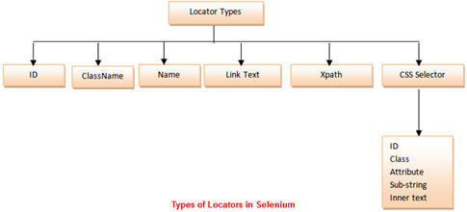](http://cdn2.softwaretestinghelp.com/wp-content/qa/uploads/2014/10/Types-of-Locators-in-Selenium-1.jpg)

We would be using “https://accounts.google.com/” for locating different types of web elements using different locator types.

### **Using ID as a Locator**

The best and the most popular method to identify web element is to use ID. The ID of an each element is alleged to be unique.

In this sample, we would access “Email” text box present in the login form at gmail.com.

**Finding an ID of a web element** **using Firebug**

**Step 1**: Launch the web browser (Firefox) and navigate to “https://accounts.google.com/”.

**Step 2**: Open firebug (either by pressing F12 or via tools).

**Step 3**: Click on the inspect icon to identify the web element.

[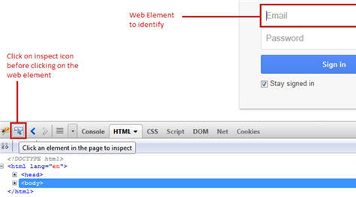](http://cdn2.softwaretestinghelp.com/wp-content/qa/uploads/2014/10/Selenium-Locators-13.jpg)

**Step 4**: Hover on the web element (Email textbox in our case) on which we desire to perform some action. In the firebug section, one can see the corresponding html tags being highlighted.

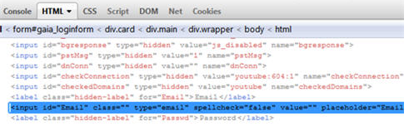

If you try to find a control and it is not well referred, it will not highlighted, and when running the script it will log not found

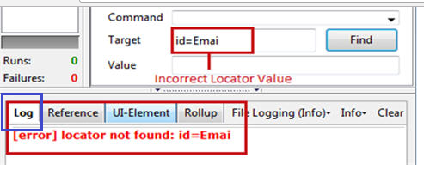

### **Using Xpath as a Locator**

Xpath is used to locate a web element based on its XML path. XML stands for Extensible Markup Language and is used to store, organize and transport arbitrary data. It stores data in a key-value pair which is very much similar to HTML tags. Both being mark up languages and since they fall under the same umbrella, xpath can be used to locate HTML elements.

The fundamental behind locating elements using Xpath is the traversing between various elements across the entire page and thus enabling a user to find an element with the reference of another element.

**Xpath can be created in two ways:**

|  |  |
| --- | --- |
| Relative Xpath | Absolute Xpath |
| //span[@class=’Email’] | /html/body/div/div[@id=’Email’] |

**Key Points:**

* The success rate of finding an element using Xpath is too high. Along with the previous statement, Xpath can find relatively all the elements within a web page. Thus, Xpaths can be used to locate elements having no id, class or name.
* Creating a valid Xpath is a tricky and complex process. There are plug-ins available to generate Xpath but most of the times, the generated Xpaths fails to identify the web element correctly.
* While creating xpath, user should be aware of the various nomenclatures and protocols.

**Selenium Xpath Examples**

**Xpath Checker**

Creating Xpath becomes a little simpler by using Xpath Checker. Xpath Checker is a firefox add-on to automatically generate Xpath for a web element. The plug-in can be downloaded from “https://addons.mozilla.org/en-US/firefox/addon/xpath-checker/”.

As soon as the plug-in is installed, it can be seen in the context menu by right clicking any element whose xpath we want to generate.

[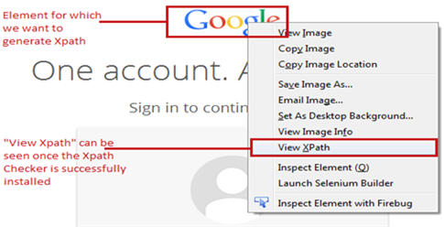](http://cdn.softwaretestinghelp.com/wp-content/qa/uploads/2014/10/Selenium-Locators-10.jpg)

Click on the “View Xpath” to see the Xpath expression of the element. An editor window would appear with the generated Xpath expression. Now user has the liberty to edit and modify the generated Xpath expression. The corresponding results would be updated cumulatively.

[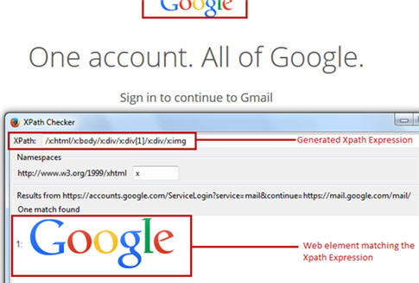](http://cdn2.softwaretestinghelp.com/wp-content/qa/uploads/2014/10/Selenium-Locators-11.jpg)

Note that the Xpath Checker is available for other browsers as well.

But re-iterating the fact, that most of the times, the generated Xpaths fails to identify the web element rightly. Thus, it is recommended to create our own Xpath following the pre defined rules and protocols.

In this sample, we would access “Google” image present at the top of the login form at gmail.com.

**Creating a Xpath of a web element**

**Step 1**: Type “//img[@class=’logo’]” i.e. the locator value in the target box within the Selenium IDE.

**Syntax:** Xpath of the element

**Step 2**: Click on the Find Button. Notice that the image would be highlighted with yellow color with a florescent green border around the field.

[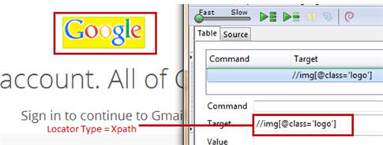](http://cdn2.softwaretestinghelp.com/wp-content/qa/uploads/2014/10/Selenium-Locators-12.jpg)

### **Conclusion**

Here are the cruxes of this article.

* Locators are the HTML properties of a web element which tells the Selenium about the web element on which it needs to perform actions.
* There is a wide range of web elements that a user may have to interact with on a regular basis. Some of them are: Text box, Button, Drop Down, Hyperlink, Check Box, and Radio Button.
* With the varied range of web elements comes a vast province of strategies/approaches to locate these web elements.
* Some of the extensively used locator types are: ID, ClassName, Link Text, Xpath, CSS Selectors and Name.

Note: Owing to the fact that creating CSS Selector and Xpath requires a lot of efforts and practice, thus the process is only exercised by more sophisticated and trained users.

**In this tutorial we learned different types of locators including Selenium Xpath.**

[**Next Tutorial #6**](http://www.softwaretestinghelp.com/css-selector-selenium-locator-selenium-tutorial-6/)**:** In continuation with this Selenium Locator types tutorial we will learn how to use **CSS Selector as a Locator.**